- Before running the program

TradeStation strategy for which trade alerts are monitored should have “Send a notification to the Tracking Center when your strategy generated an order” property checked.

From TradeStation 2000i toolbar select Go – TradeStation Strategy Builder

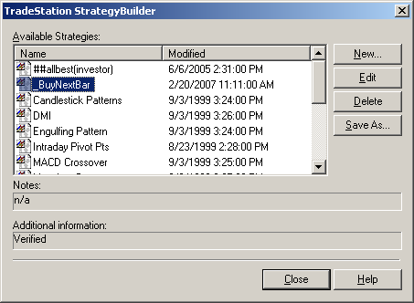

Select strategy and click “Edit” button (or create a new one)

On Position tab make sure the Additional settings is checked.
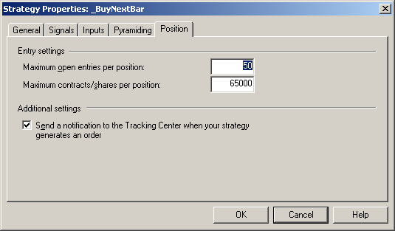

II. What should be included in the install

Program Setup should include files:

TSSignal2000i.exe
Interop.ORTCLib.dll

TSSignal2000i.exe referenced ORTC 1.0 Type Library (Ortc.exe) that is part of the standard TradeStation 2000i installation and can be found in
...\Program Files\Omega Research\Program directory.

III. Program Output

Output file example:
(Attention! Exchange name is not available and is always NA. OrderID is unique for each TradeStation chart)
date time exchange symbol signal quantity ordered
1070221 0953 NA $INDU SELL 1 11

